Справедливый Д.А ПР 23/1

Лабораторная работа №6
Тема: Разработка и интеграция модулей проекта
(командная работа)

Цель: разработать и интегрировать модуль базы данных проекта в Microsoft SQL Server, создать эффективную схему данных, обеспечивающую целостность и удобство хранения информации, а также подготовить основу для дальнейшей реализации бизнес-логики и взаимодействия с приложением с учетом командной работы.

Ход работы

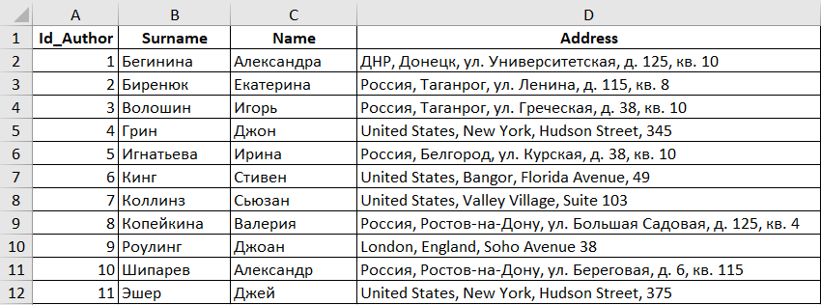
Рис. 1. Лист Authors

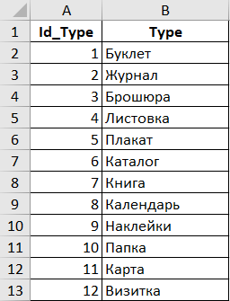
Рис. 2. Лист TypesOfProducts

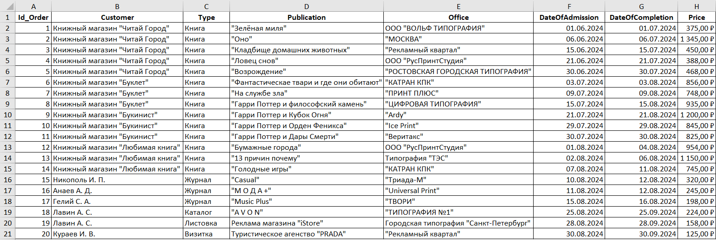
Рис. 3. Лист Orders

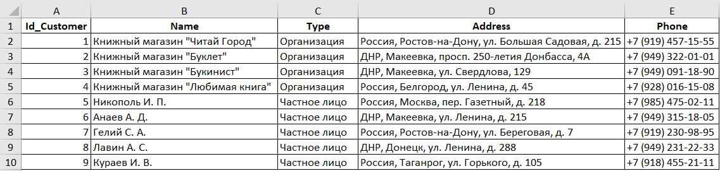
Рис. 4. Лист Customers

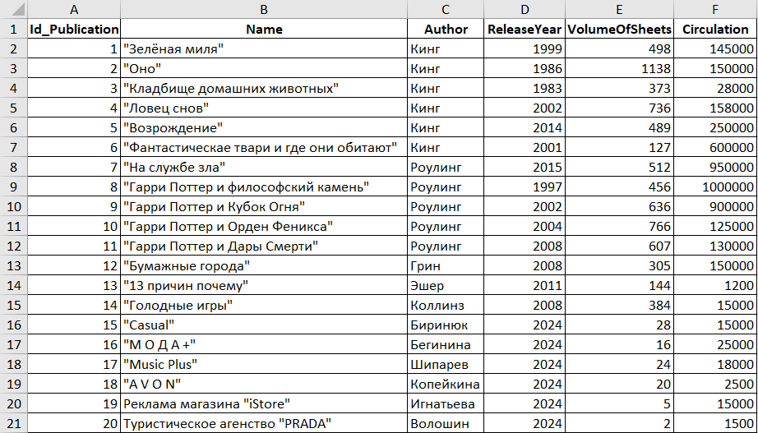
Рис. 5. Лист Publications

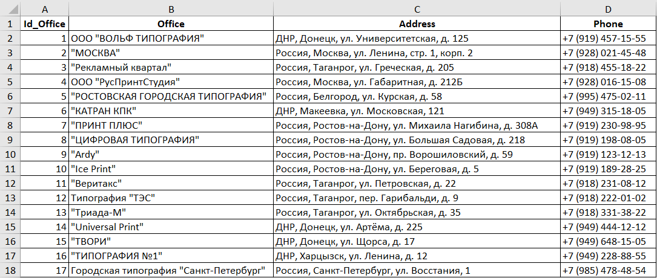
Рис. 6. Лист Offices

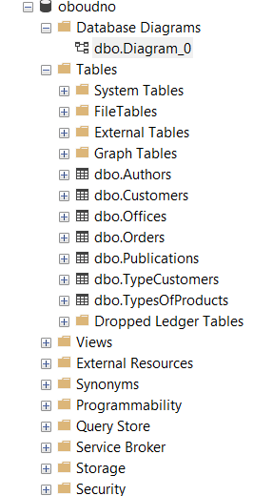
Рис. 7. Структура базы данных

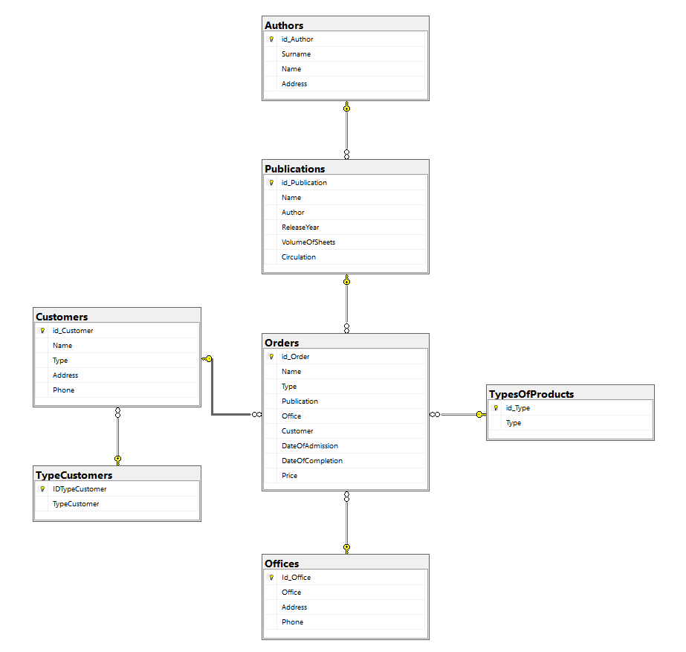
Рис. 8. Диаграмма базы данных
Листинг скрипта
USE [master]
GO
/****** Object: Database [Publishing] Script Date: 15.12.2025 19:40:53 ******/
CREATE DATABASE [Publishing]
CONTAINMENT = NONE
ON PRIMARY
( NAME = N'Publishing', FILENAME = N'C:\Program Files\Microsoft SQL Server\MSSQL16.SQLEXPRESS\MSSQL\DATA\Publishing.mdf' , SIZE = 8192KB , MAXSIZE = UNLIMITED, FILEGROWTH = 65536KB )
LOG ON
( NAME = N'Publishing_log', FILENAME = N'C:\Program Files\Microsoft SQL Server\MSSQL16.SQLEXPRESS\MSSQL\DATA\Publishing_log.ldf' , SIZE = 8192KB , MAXSIZE = 2048GB , FILEGROWTH = 65536KB )
WITH CATALOG_COLLATION = DATABASE_DEFAULT, LEDGER = OFF
GO
ALTER DATABASE [Publishing] SET COMPATIBILITY_LEVEL = 160
GO
IF (1 = FULLTEXTSERVICEPROPERTY('IsFullTextInstalled'))
begin
EXEC [Publishing].[dbo].[sp_fulltext_database] @action = 'enable'
end
GO
ALTER DATABASE [Publishing] SET ANSI_NULL_DEFAULT OFF
GO
ALTER DATABASE [Publishing] SET ANSI_NULLS OFF
GO
ALTER DATABASE [Publishing] SET ANSI_PADDING OFF
GO
ALTER DATABASE [Publishing] SET ANSI_WARNINGS OFF
GO
ALTER DATABASE [Publishing] SET ARITHABORT OFF
GO
ALTER DATABASE [Publishing] SET AUTO_CLOSE ON
GO
ALTER DATABASE [Publishing] SET AUTO_SHRINK OFF
GO
ALTER DATABASE [Publishing] SET AUTO_UPDATE_STATISTICS ON
GO
ALTER DATABASE [Publishing] SET CURSOR_CLOSE_ON_COMMIT OFF
GO
ALTER DATABASE [Publishing] SET CURSOR_DEFAULT GLOBAL
GO
ALTER DATABASE [Publishing] SET CONCAT_NULL_YIELDS_NULL OFF
GO
ALTER DATABASE [Publishing] SET NUMERIC_ROUNDABORT OFF
GO
ALTER DATABASE [Publishing] SET QUOTED_IDENTIFIER OFF
GO
ALTER DATABASE [Publishing] SET RECURSIVE_TRIGGERS OFF
GO
ALTER DATABASE [Publishing] SET ENABLE_BROKER
GO
ALTER DATABASE [Publishing] SET AUTO_UPDATE_STATISTICS_ASYNC OFF
GO
ALTER DATABASE [Publishing] SET DATE_CORRELATION_OPTIMIZATION OFF
GO
ALTER DATABASE [Publishing] SET TRUSTWORTHY OFF
GO
ALTER DATABASE [Publishing] SET ALLOW_SNAPSHOT_ISOLATION OFF
GO
ALTER DATABASE [Publishing] SET PARAMETERIZATION SIMPLE
GO
ALTER DATABASE [Publishing] SET READ_COMMITTED_SNAPSHOT OFF
GO
ALTER DATABASE [Publishing] SET HONOR_BROKER_PRIORITY OFF
GO
ALTER DATABASE [Publishing] SET RECOVERY SIMPLE
GO
ALTER DATABASE [Publishing] SET MULTI_USER
GO
ALTER DATABASE [Publishing] SET PAGE_VERIFY CHECKSUM
GO
ALTER DATABASE [Publishing] SET DB_CHAINING OFF
GO
ALTER DATABASE [Publishing] SET FILESTREAM( NON_TRANSACTED_ACCESS = OFF )
GO
ALTER DATABASE [Publishing] SET TARGET_RECOVERY_TIME = 60 SECONDS
GO
ALTER DATABASE [Publishing] SET DELAYED_DURABILITY = DISABLED
GO
ALTER DATABASE [Publishing] SET ACCELERATED_DATABASE_RECOVERY = OFF
GO
ALTER DATABASE [Publishing] SET QUERY_STORE = ON
GO
ALTER DATABASE [Publishing] SET QUERY_STORE (OPERATION_MODE = READ_WRITE, CLEANUP_POLICY = (STALE_QUERY_THRESHOLD_DAYS = 30), DATA_FLUSH_INTERVAL_SECONDS = 900, INTERVAL_LENGTH_MINUTES = 60, MAX_STORAGE_SIZE_MB = 1000, QUERY_CAPTURE_MODE = AUTO, SIZE_BASED_CLEANUP_MODE = AUTO, MAX_PLANS_PER_QUERY = 200, WAIT_STATS_CAPTURE_MODE = ON)
GO
USE [Publishing]
GO
/****** Object: Table [dbo].[Authors] Script Date: 15.12.2025 19:40:53 ******/
SET ANSI_NULLS ON
GO
SET QUOTED_IDENTIFIER ON
GO
CREATE TABLE [dbo].[Authors](
[Id_Author] [int] NOT NULL,
[Surname] [nvarchar](100) NULL,
[Name] [nvarchar](100) NULL,
[Address] [nvarchar](255) NULL,
PRIMARY KEY CLUSTERED
(
[Id_Author] ASC
)WITH (PAD_INDEX = OFF, STATISTICS_NORECOMPUTE = OFF, IGNORE_DUP_KEY = OFF, ALLOW_ROW_LOCKS = ON, ALLOW_PAGE_LOCKS = ON, OPTIMIZE_FOR_SEQUENTIAL_KEY = OFF) ON [PRIMARY]
) ON [PRIMARY]
GO
/****** Object: Table [dbo].[Customers] Script Date: 15.12.2025 19:40:53 ******/
SET ANSI_NULLS ON
GO
SET QUOTED_IDENTIFIER ON
GO
CREATE TABLE [dbo].[Customers](
[Id_Customer] [int] NOT NULL,
[Name] [nvarchar](255) NOT NULL,
[Type] [nvarchar](50) NULL,
[Address] [nvarchar](255) NULL,
[Phone] [nvarchar](20) NULL,
PRIMARY KEY CLUSTERED
(
[Id_Customer] ASC
)WITH (PAD_INDEX = OFF, STATISTICS_NORECOMPUTE = OFF, IGNORE_DUP_KEY = OFF, ALLOW_ROW_LOCKS = ON, ALLOW_PAGE_LOCKS = ON, OPTIMIZE_FOR_SEQUENTIAL_KEY = OFF) ON [PRIMARY]
) ON [PRIMARY]
GO
/****** Object: Table [dbo].[Offices] Script Date: 15.12.2025 19:40:53 ******/
SET ANSI_NULLS ON
GO
SET QUOTED_IDENTIFIER ON
GO
CREATE TABLE [dbo].[Offices](
[Id_Office] [int] NOT NULL,
[Office] [nvarchar](255) NOT NULL,
[Address] [nvarchar](255) NULL,
[Phone] [nvarchar](20) NULL,
PRIMARY KEY CLUSTERED
(
[Id_Office] ASC
)WITH (PAD_INDEX = OFF, STATISTICS_NORECOMPUTE = OFF, IGNORE_DUP_KEY = OFF, ALLOW_ROW_LOCKS = ON, ALLOW_PAGE_LOCKS = ON, OPTIMIZE_FOR_SEQUENTIAL_KEY = OFF) ON [PRIMARY]
) ON [PRIMARY]
GO
/****** Object: Table [dbo].[Orders] Script Date: 15.12.2025 19:40:53 ******/
SET ANSI_NULLS ON
GO
SET QUOTED_IDENTIFIER ON
GO
CREATE TABLE [dbo].[Orders](
[Id_Order] [int] NOT NULL,
[CustomerId] [int] NOT NULL,
[TypeId] [int] NOT NULL,
[PublicationId] [int] NOT NULL,
[OfficeId] [int] NOT NULL,
[DateOfAdmission] [date] NULL,
[DateOfCompletion] [date] NULL,
[Price] [decimal](10, 2) NULL,
PRIMARY KEY CLUSTERED
(
[Id_Order] ASC
)WITH (PAD_INDEX = OFF, STATISTICS_NORECOMPUTE = OFF, IGNORE_DUP_KEY = OFF, ALLOW_ROW_LOCKS = ON, ALLOW_PAGE_LOCKS = ON, OPTIMIZE_FOR_SEQUENTIAL_KEY = OFF) ON [PRIMARY]
) ON [PRIMARY]
GO
/****** Object: Table [dbo].[Publications] Script Date: 15.12.2025 19:40:53 ******/
SET ANSI_NULLS ON
GO
SET QUOTED_IDENTIFIER ON
GO
CREATE TABLE [dbo].[Publications](
[Id_Publication] [int] NOT NULL,
[Name] [nvarchar](255) NOT NULL,
[AuthorId] [int] NOT NULL,
[ReleaseYear] [int] NULL,
[VolumeOfSheets] [int] NULL,
[Circulation] [int] NULL,
PRIMARY KEY CLUSTERED
(
[Id_Publication] ASC
)WITH (PAD_INDEX = OFF, STATISTICS_NORECOMPUTE = OFF, IGNORE_DUP_KEY = OFF, ALLOW_ROW_LOCKS = ON, ALLOW_PAGE_LOCKS = ON, OPTIMIZE_FOR_SEQUENTIAL_KEY = OFF) ON [PRIMARY]
) ON [PRIMARY]
GO
/****** Object: Table [dbo].[TypesOfProducts] Script Date: 15.12.2025 19:40:53 ******/
SET ANSI_NULLS ON
GO
SET QUOTED_IDENTIFIER ON
GO
CREATE TABLE [dbo].[TypesOfProducts](
[Id_Type] [int] NOT NULL,
[Type] [nvarchar](50) NOT NULL,
PRIMARY KEY CLUSTERED
(
[Id_Type] ASC
)WITH (PAD_INDEX = OFF, STATISTICS_NORECOMPUTE = OFF, IGNORE_DUP_KEY = OFF, ALLOW_ROW_LOCKS = ON, ALLOW_PAGE_LOCKS = ON, OPTIMIZE_FOR_SEQUENTIAL_KEY = OFF) ON [PRIMARY]
) ON [PRIMARY]
GO
ALTER TABLE [dbo].[Orders] WITH CHECK ADD CONSTRAINT [FK_Orders_Customers] FOREIGN KEY([CustomerId])
REFERENCES [dbo].[Customers] ([Id_Customer])
GO
ALTER TABLE [dbo].[Orders] CHECK CONSTRAINT [FK_Orders_Customers]
GO
ALTER TABLE [dbo].[Orders] WITH CHECK ADD CONSTRAINT [FK_Orders_Offices] FOREIGN KEY([OfficeId])
REFERENCES [dbo].[Offices] ([Id_Office])
GO
ALTER TABLE [dbo].[Orders] CHECK CONSTRAINT [FK_Orders_Offices]
GO
ALTER TABLE [dbo].[Orders] WITH CHECK ADD CONSTRAINT [FK_Orders_Publications] FOREIGN KEY([PublicationId])
REFERENCES [dbo].[Publications] ([Id_Publication])
GO
ALTER TABLE [dbo].[Orders] CHECK CONSTRAINT [FK_Orders_Publications]
GO
ALTER TABLE [dbo].[Orders] WITH CHECK ADD CONSTRAINT [FK_Orders_Types] FOREIGN KEY([TypeId])
REFERENCES [dbo].[TypesOfProducts] ([Id_Type])
GO
ALTER TABLE [dbo].[Orders] CHECK CONSTRAINT [FK_Orders_Types]
GO
ALTER TABLE [dbo].[Publications] WITH CHECK ADD CONSTRAINT [FK_Publications_Authors] FOREIGN KEY([AuthorId])
REFERENCES [dbo].[Authors] ([Id_Author])
GO
ALTER TABLE [dbo].[Publications] CHECK CONSTRAINT [FK_Publications_Authors]
GO
USE [master]
GO
ALTER DATABASE [Publishing] SET READ_WRITE
GO
Вывод: я выполнил импорт данных из Excel в SQL Server, сделал диаграмму и сохранил скрипт БД.

